This is the Template for FEZA2026 abstract preparation, please use the styles reported in red from the style menu of MS Word.
TITLE (STYLE: FEZA2026_TITLE)
Authors must be listed with the name first letter followed by entire surname, each separated by commas. The presenting author's name is underlined W. Shakespeare¹, D. Alighieri¹ (FEZA2026_Autorship)
1 Name of the Institution and full address. (max one row each) the underlined is the presenting author (FEZA2026_Affiliation)
Corresponding: e-mail address of the corresponding author (and full name under parentheses). dante.alighieri@gmail.com (FEZA2026_email)
- INTRODUCTION (FEZA2026_Paraghaph_title)
Text, maximum 800 characters (including spaces). (FEZA2026_Text)
- RESULTS AND DISCUSSION
No length limitations, Charts and Tables should be inserted only in this section. (FEZA2026_Text)
- EXPERIMENTAL
Optional section, maximum 1000 characters (including spaces). (FEZA2026_Text)
- CONCLUSIONS
No length limitations, (FEZA2026_Text)
References (FEZA2026_Reference_Head)
[1] A. Author, B. Author, and C. Author (Year) Journal, Volume, Pages. (FEZA2026_Reference)
[2] A. Author, Title of Book, (Year) Publisher, City.
[3] A. Author and B. Author (Year) Conference name, Dates, City, Country, Page

Guidelines for Figures and Tables

Tables, figures and graphics must be numbered and accompanied by a legend. The figure captions must be below the figures, whilst the table captions must appear above them. All figures and tables must be referenced in the main text. Charts scale and points must be clearly readable. A maximum of five figures or tables can be inserted

Table 1 - Table caption in one row (FEZA2026_Figure-Table_caption)  Catalyst xxxx xxx  Cat1 xx xx  Cat2 xx xx |   Figure 1 - Figure Caption in one row (FEZA2026_Figure-Table_caption)

IMPORTANT NOTICES:
- The abstract must be written in English
- The abstract must stand within 2 pages
- The abstract must include only the section listed above, in the same order.
- In red are listed the reference styles to be adopted
Please copy this template to your computer and insert the text keeping the format and styles indicated. It is important, that the abstract will focus on the most relevant results of the work and relevant references. The inclusion of tables, figures and graphics is optional. If any, they must be included following the indicated guidelines. Abstracts must be written in English [1-3]. Cite references using square brackets.
The abstract must be sent in Word Format (.doc or .docx) through the submission form available at the conference website.

Communications sent by any other means than the submission through the Congress website will not be considered.

During the submission process, you must indicate the preferred presentation mode (oral or poster), as well as the topic that best fits the content of the research.

The contact person for further notifications is the corresponding author and you must indicate who will be the presenting author.

The final acceptance of the contribution is subjected to the registration of the presenting author including the fee payment.

Any registered person can act as presenting author for a maximum of 1 oral and/or 1 poster contribution

In the next page an example of abstract is provided and can used as a further reference to format your abstract.

(The reference abstract has been generated by AI, any content, INCLUDING NAMES, INSTITUTIONS EMAIL ADRESSES, is not real)

IMPORTANT
Along with the abstract, it is mandatory to submit a summary (500 characters minimum – 800 characters maximum) directly throught the website submission page. This summary must include only a statement on the scientific background motivating the research, the novelty of the contribution and the main results. Avoid any state-of the-art/introduction sentences.

In the summary the Authors should go straight to the scientific details and this text will be strongly considered in the pre-evaluation process.

Contributions without a summary will be not considered.

DO NOT INSERT THE SUMMARY HERE

Application of Synthetic Zeolites for Heavy Metal Adsorption in Aqueous Solutions
A. Müller¹, L. Rossi¹, Y. Tanaka², L. Wei², C. García-López³
1 European University, Department of Chemical Engineering, Berlin, Germany
2 Asia State University, Department of Materials Science, Tokyo, Japan
3 Latin American University, Department of Environmental Engineering, Mexico City, Mexico
Corresponding: luca.rossi@europeuniv.eu (Luca Rossi)
- INTRODUCTION
Heavy metal contamination of water resources is a critical environmental and public health issue worldwide. Metals such as lead (Pb²⁺), cadmium (Cd²⁺), and mercury (Hg²⁺) are highly toxic even at very low concentrations and can bioaccumulate in organisms, posing long-term risks to ecosystems and human health. Conventional water treatment methods often fail to remove these pollutants efficiently. Synthetic zeolites, with their microporous structure, high cation exchange capacity, and chemical stability, provide a sustainable solution. Their properties can be tuned to target specific metal ions, enabling effective removal from water. Zeolites’ durability and reusability make them environmentally friendly and cost-effective, offering a versatile approach to mitigate heavy metal pollution.
- RESULTS AND DISCUSSION
X-ray diffraction (XRD) (Fig. 1) patterns confirmed that the synthesized zeolites Z1 and Z2 possess well-defined crystalline structures, with sharp and intense reflections that can be unambiguously attributed to the targeted framework topologies.
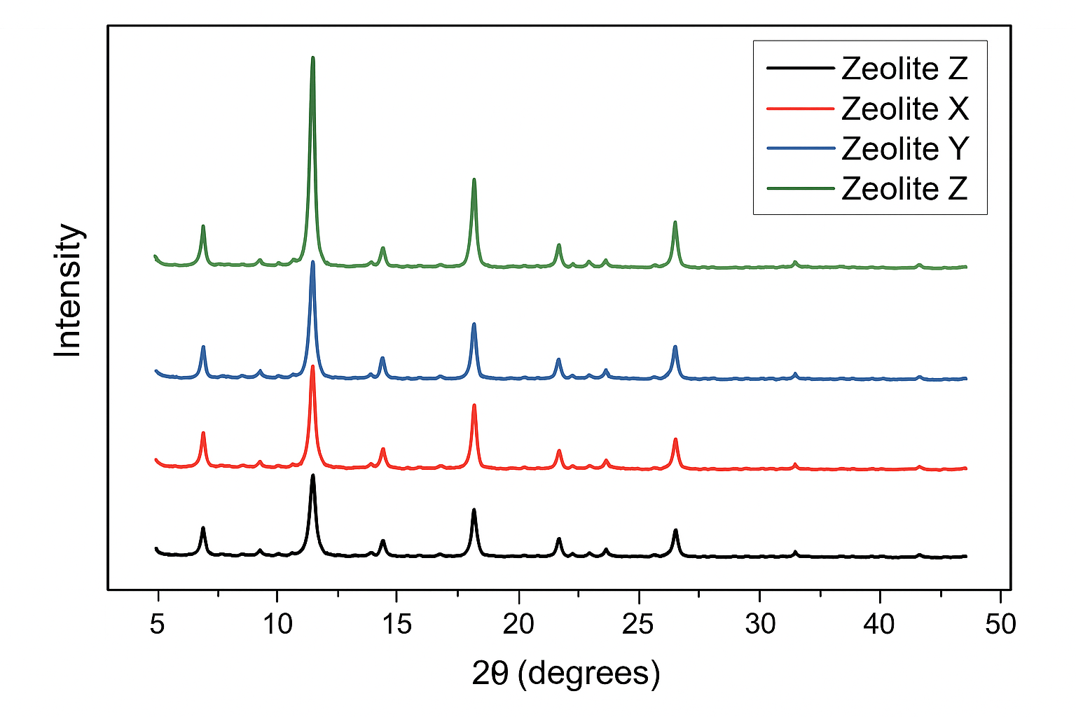
Figure 1 - XRD Patterns of Zeolites
The presence of distinct diffraction peaks indicates the absence of amorphous phases and confirms that the synthetic procedure yielded products with high crystallinity. In particular, the peak positions correspond well with those reported in the literature for analogous zeolitic materials, further validating the successful synthesis. Subtle differences in peak intensities between Z1 and Z2 are consistent with variations in their Si/Al ratios, suggesting that framework composition influences not only cation distribution but also overall lattice stability.
Complementary morphological characterization was performed by scanning electron microscopy (SEM). The SEM micrographs revealed clear contrasts between the two materials. Zeolite Z1 is characterized by a uniform particle size distribution, with crystallites appearing relatively small and regularly shaped, thereby providing a high external surface area available for adsorption processes. Conversely, Z2 displays larger and more irregular crystallites, reflecting its higher Si/Al ratio and the consequent tendency toward more rigid framework formation.
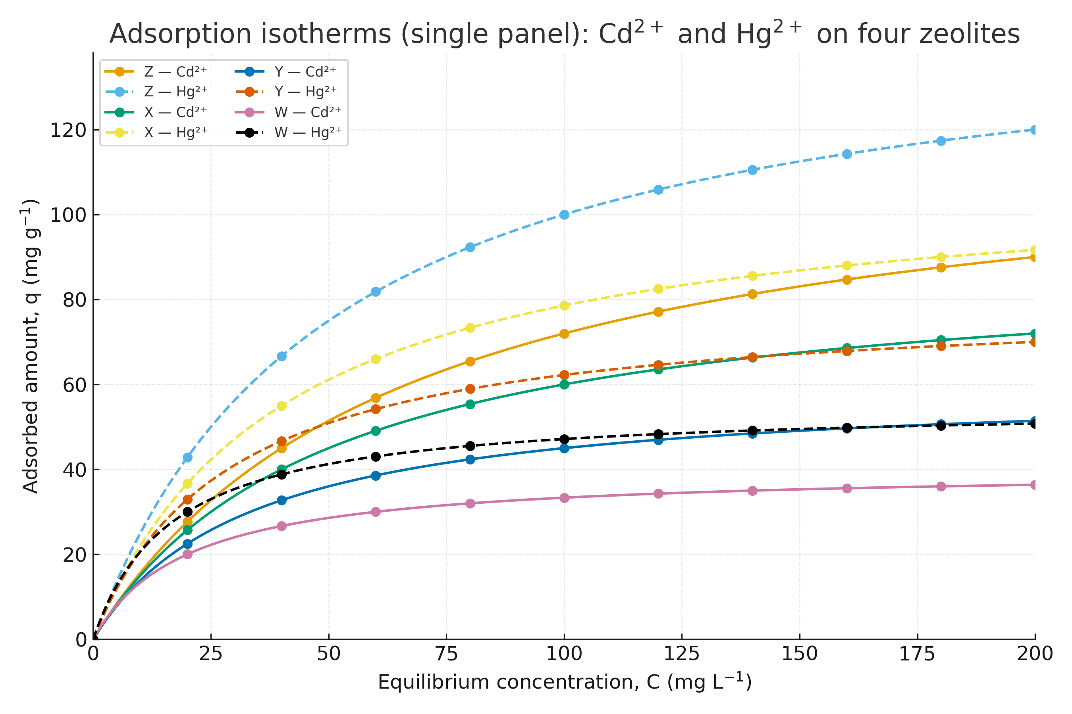Figure 2 – Adsorption Isotherms
Batch adsorption experiments (Fig. 2) demonstrated clear differences in the performance of the two zeolitic frameworks. Zeolite Z1, with its lower Si/Al ratio, exhibited superior adsorption capacities for Pb²⁺ and Cd²⁺, achieving maximum values of 120 mg/g and 95 mg/g, respectively. This can be attributed to the higher density of negative framework charges associated with the lower Si/Al ratio, which enhances the abundance of cation exchange sites. In contrast, Z2, while less efficient in adsorbing Pb²⁺ and Cd²⁺, exhibited a more stable and selective uptake of Hg²⁺ (50 mg/g). The enhanced Hg²⁺ affinity of Z2 is likely related to its more rigid and hydrophobic framework, which facilitates stabilization of larger cations within the zeolitic channels. These results (Tab.1) highlight the importance of framework composition in dictating adsorption selectivity and efficiency.
Table 1 – Adsorption values
Zeolite | Si/Al | Pb²⁺ (mg/g) | Cd²⁺ (mg/g) | Hg²⁺ (mg/g)
Z1 | 1.5 | 120 | 95 | 40
X | 2.0 | 110 | 85 | 90
Y | 3 | 150 | 75 | 50
Z2 | 1 | 125 | 85 | 35
Adsorption kinetics were monitored over a period of 180 minutes. For both zeolites, the experimental data fitted well to the pseudo-second-order kinetic model, with correlation coefficients R² consistently greater than 0.99. This strongly suggests that chemisorption, involving valence forces and electron sharing between the adsorbent and adsorbate, is the dominant mechanism. As shown in Fig. 2, the time-dependent adsorption profiles revealed a rapid initial uptake, attributable to the abundance of unoccupied active sites, followed by a slower approach to equilibrium as site saturation occurred. Pb²⁺ adsorption reached equilibrium after approximately 120 minutes, whereas Cd²⁺ and Hg²⁺ required slightly longer contact times, likely due to differences in ionic radius and hydration energies.
The thermodynamic parameters calculated from experiments conducted at 25, 35, and 45 °C provide further insight into the adsorption process. Positive values of ΔH° confirm the endothermic nature of metal ion uptake, indicating that higher temperatures enhance adsorption efficiency.
Table 2– Efficiency after 5 cycles %
Zeolite | Si/Al | Pb²⁺ | Cd²⁺ | Hg²⁺
Z1 | 98 | 95 | 95 | 96
X | 99 | 92 | 85 | 90
Y | 76 | 99 | 82 | 50
Z2 | 75 | 100 | 90 | 45
Negative ΔG° values at all investigated temperatures demonstrate that the process is thermodynamically spontaneous, while positive ΔS° values suggest increased disorder at the solid–liquid interface during adsorption, possibly due to partial release of water molecules from hydrated metal ions as they bind to the zeolite surface. These findings align with previously reported behavior for zeolite-based adsorbents used in heavy metal remediation. The calculated maximum monolayer adsorption capacities (q_max) are in close agreement with experimental values, as summarized in Table 1, confirming the reliability of the adsorption measurements.
The practical applicability of the materials was assessed through regeneration experiments. As shown in Tab. 2, both Z1 and Z2 retained high removal efficiencies after five consecutive adsorption–desorption cycles. Specifically, Z1 preserved 92% of its initial capacity, while Z2 maintained 88%. These results highlight the robustness and stability of the synthetic zeolites under repeated operational conditions, suggesting their suitability for long-term water treatment applications. The relatively minor decline in performance can be attributed to partial pore blockage or residual ion retention but does not compromise their overall efficiency.
- EXPERIMENTAL
Synthetic zeolites Z1 and Z2 were prepared via hydrothermal synthesis using sodium silicate and aluminum sources, with Si/Al ratios of 1.5 and 2.0, respectively. The mixtures were aged at room temperature and then crystallized at 100°C for 24 hours. Solid products were filtered, washed, and dried at 80°C. Structural characterization was performed using X-ray diffraction (XRD), Fourier-transform infrared spectroscopy (FTIR), and scanning electron microscopy (SEM) to assess crystallinity, functional groups, and morphology. Batch adsorption experiments were carried out by contacting 0.5 g of zeolite with 100 mL of metal ion solutions (Pb²⁺, Cd²⁺, Hg²⁺) at varying concentrations and pH values. Adsorption kinetics and isotherms were determined by sampling at different time intervals and analyzing metal concentrations with atomic absorption spectroscopy. Regeneration studies involved washing spent zeolites with 0.1 M NaCl solution and reusing them for five consecutive adsorption cycles.
- CONCLUSIONS
Synthetic zeolites demonstrated high efficiency in removing heavy metals from aqueous solutions. Z1, with a lower Si/Al ratio, excelled in Pb²⁺ and Cd²⁺ adsorption, while Z2 provided stable Hg²⁺ removal due to its more robust framework. Adsorption followed pseudo-second order kinetics and was spontaneous and endothermic. Regeneration tests confirmed minimal loss of performance over five cycles, highlighting reusability. These results confirm that synthetic zeolites are versatile, sustainable, and promising candidates for industrial-scale water treatment, with tunable properties allowing optimization for specific contaminants.
References
[1] A. Müller, L. Rossi, and Y. Tanaka (2022) Journal of Environmental Materials, 16, 145–160.
[2] Y. Tanaka, L. Wei (2021) Applied Clay Science, 203, 106450.
[3] C. García-López and M. Hernández, Advanced Materials for Environmental Remediation, (2020) Springer, Berlin.
[4] S. Kim and H. Zhang (2021) 12th Intern. Conf. on Environmental Engineering, 15–18 June, Tokyo, Japan, 78–85.

